
BEMBRIDGE PARISH COUNCIL

5 Foreland Road, Bembridge, Isle of Wight, PO35 5XN
Tel: 01983 874160

Service Fees Report
The BPC provide cemetery and pitch/changing room services. The current fees are as follows:
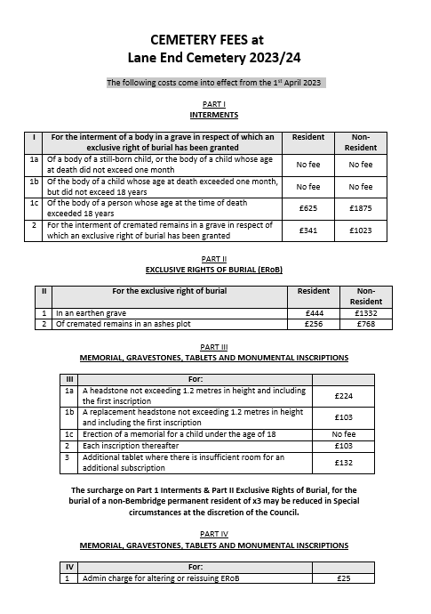
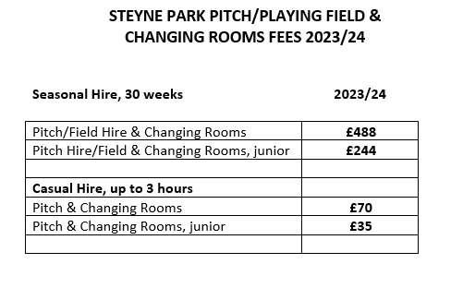
These fees incorporated an increase of 10% on 2022/23 fees to reflect inflation, agreed at Full Council in May 2023. (Note: there had been no increase in fees between 2021/22 and 2022/23)
UK inflation in January 2024 was 4%.

Currently the teams paying for pitch/changing room hire are:
Bembridge FC (adult) – 3 teams
Bembridge FC (youth) – 7 teams
Brading Colts (youth) – 2 teams
High Park Tavern (adult) – 1 team

The following comments have been received from representatives of Bembridge FC (adult):
‘……we do lots of pitch and changing room maintenance ourselves, would be nice if this is considered on the pricing.
We repair all the goalmouths in the summer, seed different areas, repair pitch damage from games and not just our own games through the season. Do loads of other work on the changing rooms as well.
Provide all our own nets, corner flags, pegs etc etc.
I think on the agreement maintenance and providing everything is not all down to us. We're happy to do it but maybe consider our pricing?’

It should also be noted that income from cemetery fees in 2023/24 is forecast to be above the budgeted expectation for the year.

The Committee need to consider their recommendations to Full Council:
- Increase fees by inflation.
- Increase fees by more or less than inflation.
- Keep fees stable.
- Decrease fees.

Thank you,
Mark Rochell
RFO.

