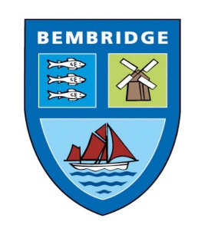
BEMBRIDGE PARISH COUNCIL

5 Foreland Road, Bembridge, Isle of Wight, PO35 5XN
Tel: 01983 874160

Finance & Governance Committee

Recommendations to Bembridge Parish Council Full Council meeting, following meeting held on Tuesday 13th February 2024 of Finance and Governance Committee

- Community Action Isle of Wight’s Rural Housing Needs Enabler is contracted to carry out the full processing and analysis of the Housing Needs Survey Questionnaires at proposed cost.

- Subject to the provision of a fully completed application form, the following donations are agreed:

- £1,000.00 to the Bembridge Friendship Circle to cover the cost of community bus insurance. Note: a request will also be made for the Parish Council donation to be recognised.
- £338.40 to the Bembridge Street Fair 2024 to cover cost of St John’s Ambulance support for the event.
- Up to £300 to the Bembridge Street Fair 2024 to cover the cost of insurance for the event.

- That the Council enter a 24-month, pay monthly contract for a Galaxy AO5S mobile phone for office use.

- Following analysis of the Toilet Cleaning Contract Report, that the Full Council agree to toilet cleaning maintenance being brought ‘in-house’ on a 6-month trial basis.

- Following analysis of the Grounds Maintenance Contract Report, that the Full Council agree to a new three-year contract, with annual performance reviews, be agreed with John O’Conners.

