Site Inspection Report
Safety Assessor:  John Tyler |  |  |  |  | Date Inspected:  27 September 2023 |  |  |  |  |  | Time Inspected:  10.00 – 13.30
BPC Representatives:  Julia Shorrocks  Steve Davidge |  |  |  |  | Location:  BPC Offices & Lengthsmens Hut |  |  |  |  |  | Nature of Works:  Local Council
Key |  | Satisfactory | √ | Unsatisfactory |  | X |  | Not Applicable |  |  |  | N/A | Not Checked |  | N/C
Ref. | Inspected Item |  |  |  | Check |  | Ref. |  | Inspected Item |  |  |  |  | Check
 | Monitoring & Control |  |  |  |  |  |  |  | General Site Activities
1. | Supervision of work |  |  |  | √ |  | 20. |  | Prescribed Signs & Notices |  |  |  |  | √
2. | Registers & Certificates |  |  |  | N/A |  | 21. |  | Site Access and Egress |  |  |  |  | √
 |  |  |  |  |  |  | 22. |  | Site Security & Demarcation |  |  |  |  | √
 | Occupational Health |  |  |  |  |  | 23. |  | Pedestrian Routes & Roadways |  |  |  |  | √
3. | COSHH & Hazardous Substances |  |  |  | X |  | 24. |  | Tidiness |  |  |  |  | √
4. | Manual Handling |  |  |  | √ |  | 25. |  | Overhead Power Cables |  |  |  |  | N/A
5. | Noise And Vibration |  |  |  | √ |  | 26. |  | Lighting |  |  |  |  | √
6. | Mess Facilities, Drinking Water |  |  |  | √ |  | 27. |  | Public Safety |  |  |  |  | √
7. | Washing & Toilets |  |  |  | √ |  | 28. |  | Traffic Management |  |  |  |  | √
8. | Office Cleanliness & Integrity |  |  |  | √ |  | 29. |  | Personal Protective Equipment |  |  |  |  | √
9. | First Aid |  |  |  | √ |  | 30. |  | Underground Services |  |  |  |  | √
 |  |  |  |  |  |  | 31. |  | Storage of Materials |  |  |  |  | √
 | Environmental Issues |  |  |  |  |  | 32. |  | Work at Height |  |  |  |  | X
10. | Noise & Vibration |  |  |  | X |  | 33. |  | Excavations |  |  |  |  | √
11. | Light Pollution Control Measures |  |  |  | √ |  | 34. |  | Barriers & Fencing |  |  |  |  | √
12. | Air Pollution Control Measures |  |  |  | √ |  | 35. |  | Plant and Equipment |  |  |  |  | X
13. | Land Pollution Control Measures |  |  |  | √ |  | 36. |  | Confined Spaces |  |  |  |  | N/A
14. | Water Pollution Prevention |  |  |  | √ |  | 37. |  | Abrasive Wheels |  |  |  |  | N/A
15. | Waste Management |  |  |  | √ |  | 38. |  | Fire |  |  |  |  | X
16. | Compliance With Consents & Licences |  |  |  | N/A |  | 39. |  | Temporary Electrical Supplies |  |  |  |  | √
 |  |  |  |  |  |  | 40. |  | General Observations |  |  |  |  | √
 | Quality Management
17. | Inspection & Test Plans (WAIF’s) |  |  |  | √
18. | Briefing & Records |  |  |  | X
19. | Temporary Works |  |  |  | √
Any items marked as unsatisfactory must be referenced on page 4, along with proposed remedial actions and time frames for completion.

General Comments

As part of the annual review of H&S Risk Assessments, a visit to the Bembridge Parish Council (BPC) Offices and Lengthsmens’ Hut was carried out.

The overall standards of the management of health & safety was satisfactory, however some areas were identified which should be considered as part of an overall H&S Improvement Plan.

The BPC Offices were clean and tidy. Procedures are in place for the main hazards encountered by the Clerks, in particular lone working, fire safety management, slips, trips and falls and Display Screen Assessments.

The Lengthsmens’ Hut was generally tidy and well-organised, however some areas for improvement were identified, in particular around plant & machinery, working at height, control of chemicals, control of noise & vibration and statutory inspections.

2 long ladders were observed which, whilst in good condition, had not received a statutory inspection as required by the Working at Height Regulations. Use of the ladders involves working at a height of greater than 2m, however there is no Working at Height Policy or task specific risk assessment for the use of ladders.

The Lengthsmens’ duties involve frequent use of vibrating plant & machinery, including mowers, strimmers and hedge cutters. PPE is provided for use during the operation of this plant, in particular ear defenders, visors and gloves. It was apparent that Noise & Vibration exposure levels had not been determined, which could lead to excessive exposure to noise (resulting in tinnitus or hearing loss) and vibration (resulting in Vibration White Finger, Hand Arm Vibration Syndrome and Whole Body Vibration Syndrome).

Maintenance of plant & machinery is mainly carried out by the lengthsmen, however some specialist maintenance is carried out by an external contractor. A long handled hedge trimmer was seen in the Lengthsmens Hut which had an exposed electrical cable. This needs to be withdrawn from use and repaired. A “ride on mower” was seen in the Lengthsmens Hut. This is not used on a regular basis, however it should nevertheless be subject to annual maintenance and inspection programme, or withdrawn from service.

PAT Testing is carried out annually by annually by an external contractor. There were some items in the Lengthsmens Hut which had not been inspected – including a cement mixer and a radio.

An external storage cage is provided for chemicals in the Lengthsmens’ yard, however petrol was observed in the Lengthsmens Hut which is a fire hazard. COSHH Assessments or Sypol Safety Data Sheets were not available for chemicals in use by the Lenghtsmen. The cleaning contractor uses her own chemicals for cleaning the public toilets and it is unlikely she has the relevant COSHH Assessments for use of these chemicals.

All items marked as unsatisfactory must be referenced below, along with actions required to remedy sub-standard conditions, a risk category according to the potential for injury/damage (see table below), and a person accountable for completion of the actions. When all actions required are complete, the completion date should be filled in to signify thus.

Item | Ref. | Description of unsatisfactory condition/Positive Comments | Action | Cat. | Owner
1 | 35 | The long-handled hedge trimmer had exposed electrical cables. | Withdraw from use until repaired. | A | BPC
2 | 18 | The Lengthsmen had not been briefed on the H&S Risk Assessments. | John Tyler will deliver briefing. | C | John Tyler
3 | 10 | Noise & Vibration Risk assessments had not been carried out for the mowers, hedge cutters and strimmers. | Consideration to be given to assessing Noise & Vibration Exposure Levels | C | BPC
4 | 32 | No Working at Height Policy exists for use of ladders | Develop Working at Height Policy | C | BPC
5 | 35 | The “ride on” mower did not have a current statutory inspection. | Arrange a statutory inspection or withdraw from use and label accordingly | C | BPC
6 | 35 | The cement mixer did not have a current PAT Test | Undertake PAT Test. | B | BPC
7 | 32 | Ladders are not subject to annual H&S inspections | Develop inspection programme and maintain records. | C | BPC
8 | 3 | COSHH Assessments or Sypol Data Sheets are not provided for chemicals in regular use. | Provide relevant assessments and brief to affected employees. | C | BPC

Photographs

Damaged cable of Long Handled Hedge Trimmer (item 2)

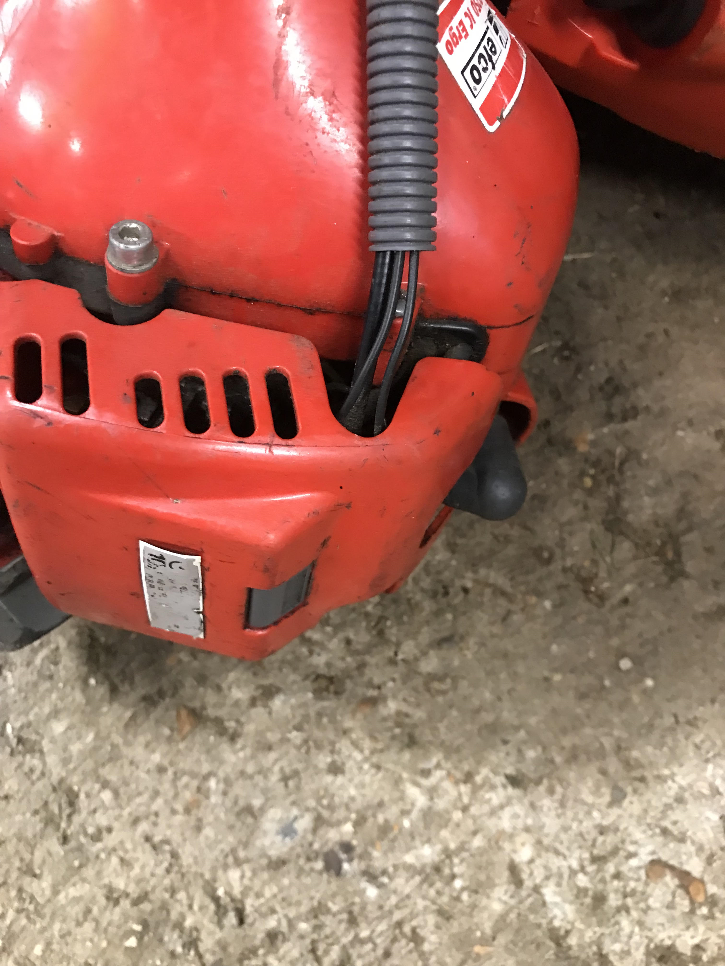

Category | Definition | Action
A  (Major / High Potential) | Substandard action or condition with the potential to result in fatal or major injury, or serious damage to equipment, infrastructure or environment | Rectify immediately
B  (Medium Potential) | Substandard action or condition with the potential to result in significant other injuries (i.e. minor) or minor damage to equipment, infrastructure or environment | Rectify within 28 days
C  (Minor / Low Potential) | Substandard action or condition, which, whilst not resulting in injury or damage, falls below the requirements and standards. | Consider improvement action

 | Name (Print) | Signature | Date
Person carrying out Inspection | John Tyler | John Tyler | 28/09/23

