
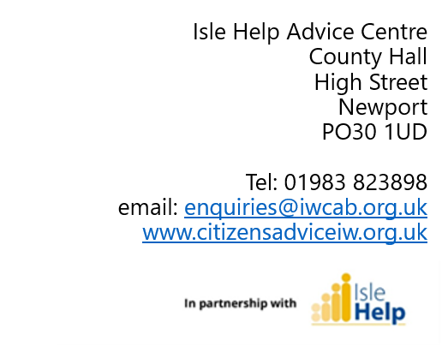
15 June 2023

Bembridge Parish Council

Dear Chair and Council members,

Citizens Advice Isle of Wight is a local independent charity and continues to provide free, impartial, and independent advice to anyone who needs it. We hold the Advice Quality Standard for the quality of advice we give, and our advisers go through a comprehensive training program to ensure they meet the standards required to offer a trusted service for Islanders.
Over the last three years we have continued to adapt our services to the new and varied demands placed on us all by the pandemic, the cost of living crisis and new preferred communication channels. All our Advisers have needed laptops and phones to work from home or in the community. We are very proud of the service they have delivered, and are extremely confident that they will meet and overcome the expected challenges which are now surfacing on the Island.

What Have We Been Doing?
Our Advice First Aid project, launched just before the pandemic started, now benefits from Citizens Advice having trained over 200 signposting volunteers across the Island. Advice First Aiders (AFAs) are local community trusted sources of information such as librarians, councillors, clerks, hairdressers, charity workers and school secretaries, who use our local website Isle Find It to signpost services available where they live or work. We recruited many people running the amazing Warm Spaces that ran over the winter during the current cost of living crisis.
We answered even more telephone calls from worried Islanders (over 800 calls per month) whilst still being available to have face-to-face appointments when needed at the Advice Centres in Newport and Ryde or other community venues. We do our best to have advisers at the Foodbanks and the Our Place events in Freshwater and Ventnor.
We have collectively raised the income for our clients to over £1.1 million and resolved around £400,000 of problem debts.

Focus on Bembridge
Between 1.04.22 and 31.03.23, we advised 70 clients with a total of 174 issues from the Bembridge area. The most common issue was Benefits, followed by Health and Community Care. If you require any further information, please get in touch with me, or visit our website – details at the top.

We would not be able to do what we do without our fully trained volunteer advisers who make up the majority of our work force. They work alongside our staff and provide vital support so that together we can reach across the Island to those who need advice. The average cost of an Adviser is £972 a year (£18.69 weekly), which covers their training, equipment, and expenses. We currently have x volunteers working with us and the support of local donations allows us to keep their knowledge and training up to date.
Given our activity in your area we would be very grateful if you were able to consider Citizens Advice IW again this year when drawing up your list of grants or donations to pay towards the expenses and costs of advisers supporting your residents.
You have one Advice First Aider in your area. If you would like to have more, please contact Simonb@iwcab.org.uk who can explain how easy it is to become an AFA.
We would also be delighted to come and present information on the work we do to your Council.
Thank you in anticipation for considering us.

Yours sincerely
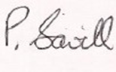
Paul Savill
Chief Officer

