
BEMBRIDGE PARISH COUNCIL

5 Foreland Road, Bembridge, Isle of Wight, PO35 5XN
Tel: 01983 874160

Projector recommendations to Finance & Governance Committee

Option 1 – BenQ TH575 – £549.00

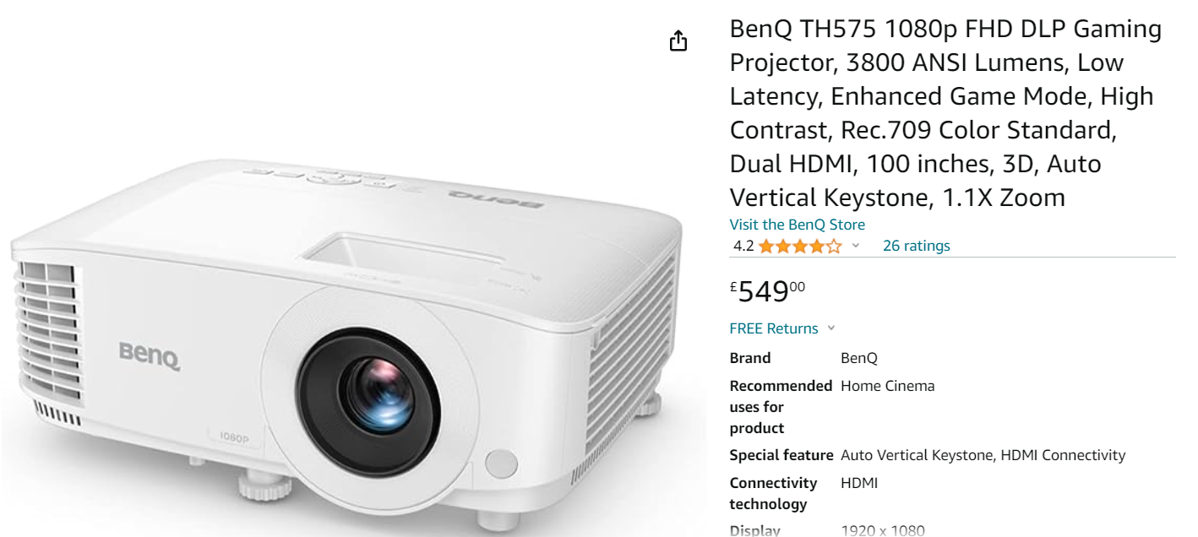

Option 2 – 5 Epson E8-WO6 £473.00, Acer X1328WHK £414.00, BenQ TH671ST £799.00 or Epson CO-WO1 £389.00

