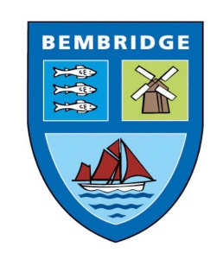
BEMBRIDGE PARISH COUNCIL

5 Foreland Road, Bembridge, Isle of Wight, PO35 5XN
Tel: 01983 874160
Mark Rochell : RFO Bembridge Parish Council

31st July 2023
Public Toilets Forward Plan

Bembridge Parish Council are responsible for the maintenance of 4 public toilets in the village.

The locations of these toilets are;

- The Point
- The Lifeboat Centre
- The Village Hall
- Steyne Park

I attach below, pictures showing the current condition of each of these facilities:

The Point

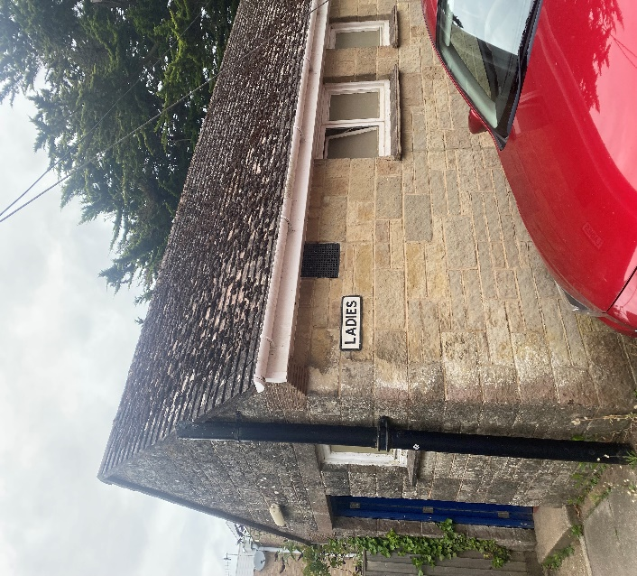
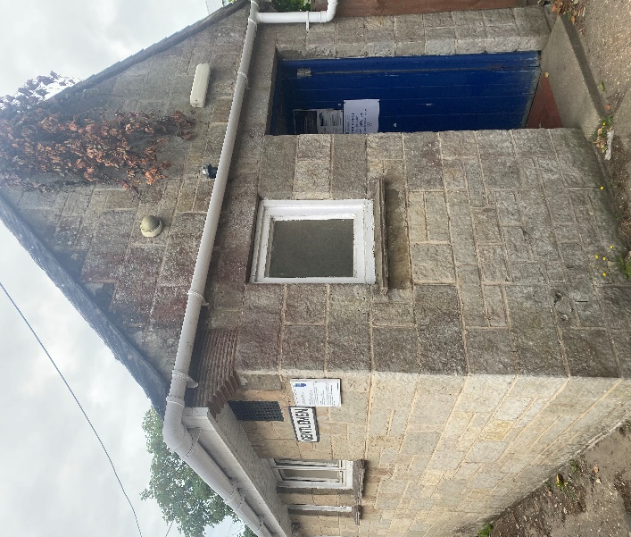The point exterior
The Point exterior

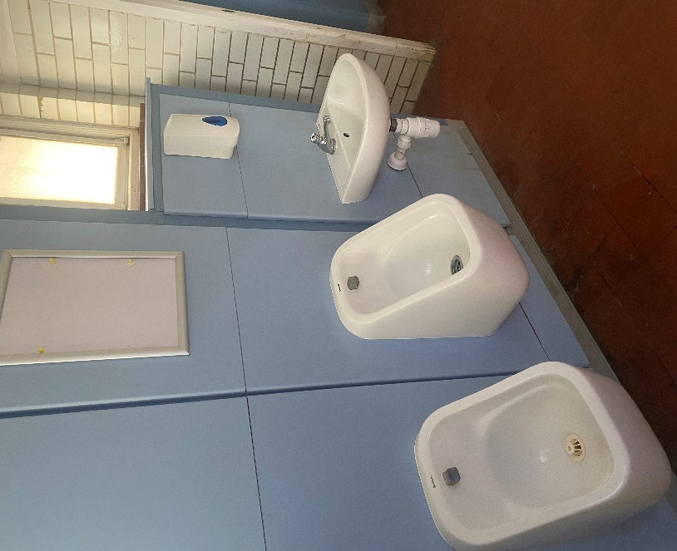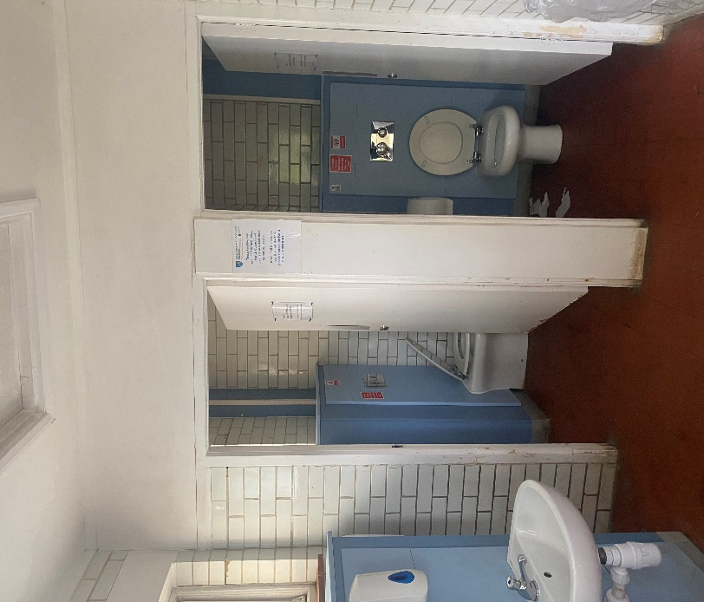
The Point interior

The Lifeboat Station

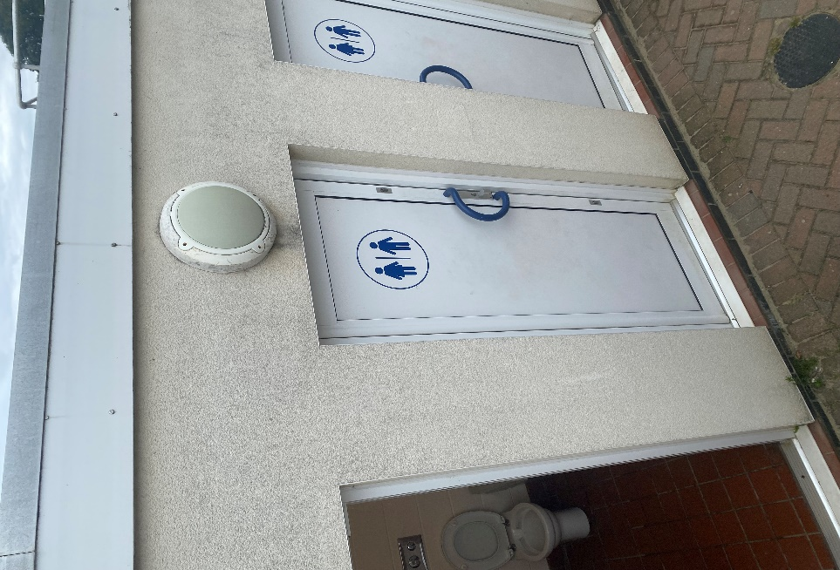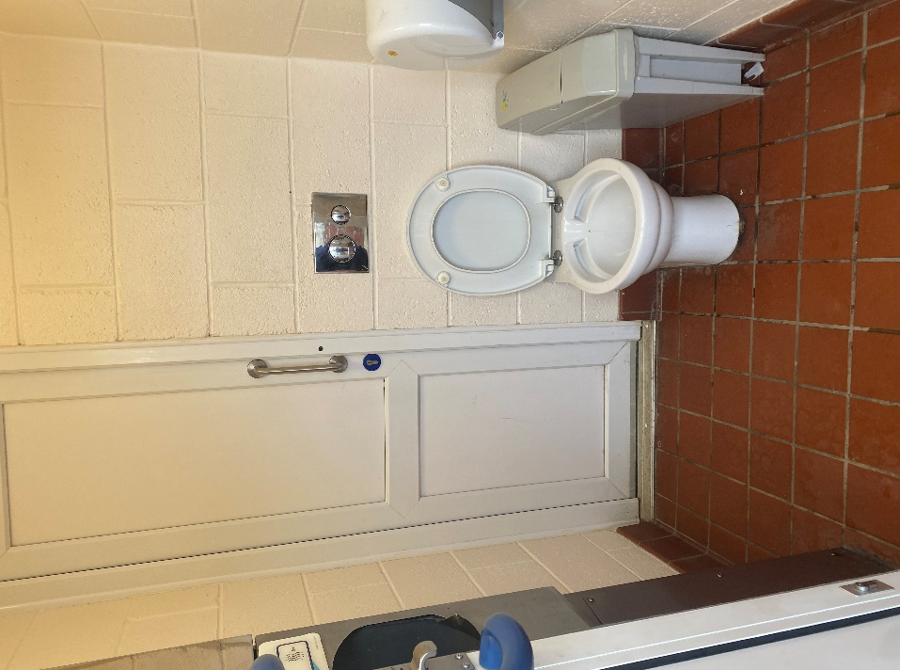
Lifeboat exterior Lifeboat interior

The Village Hall

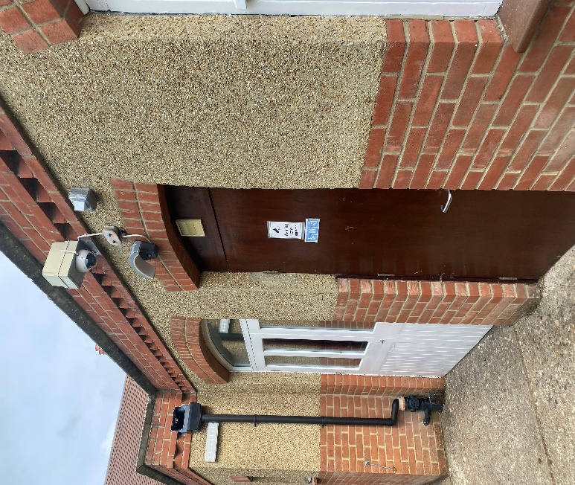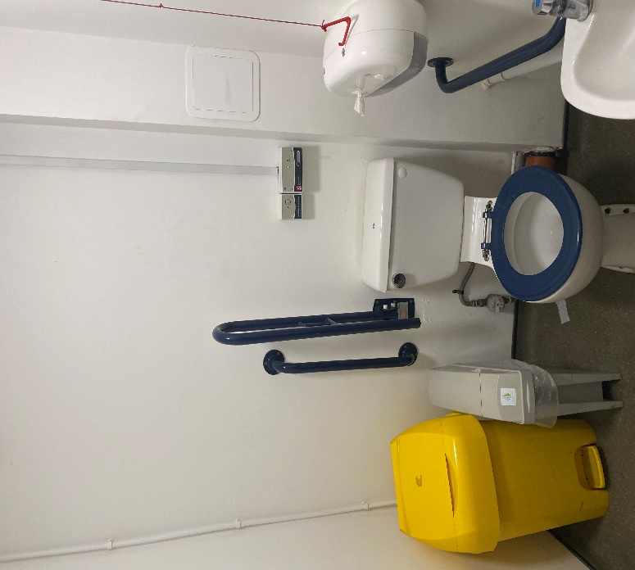
Village Hall exterior Village Hall interior

Steyne Park

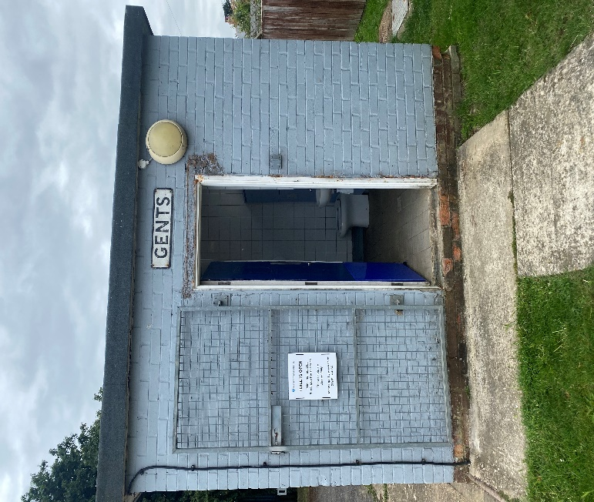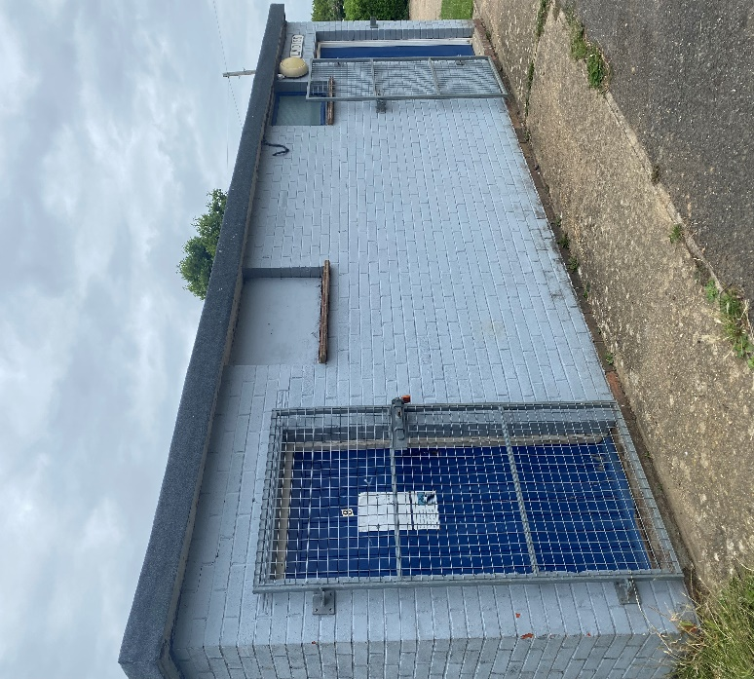
The Park exterior

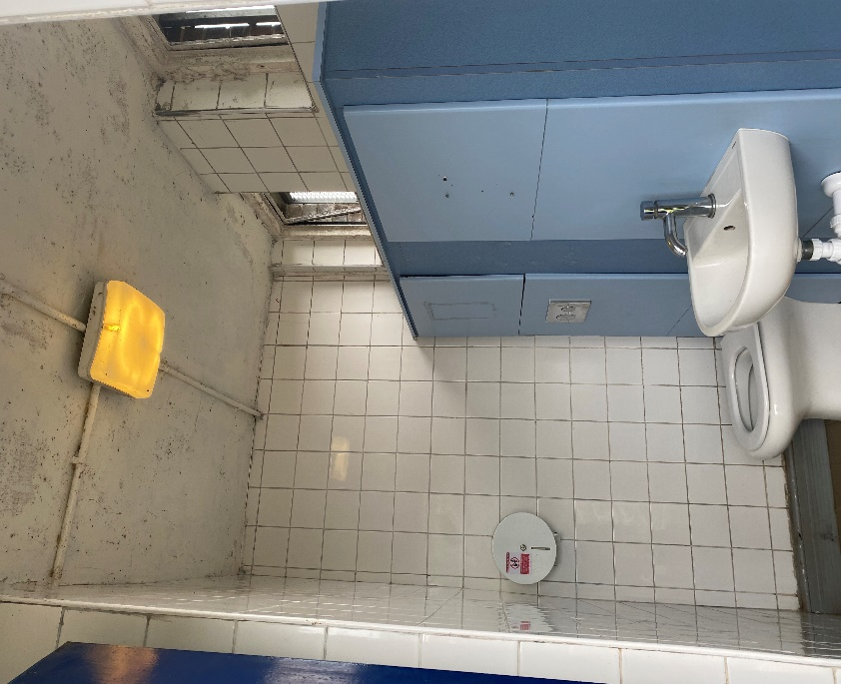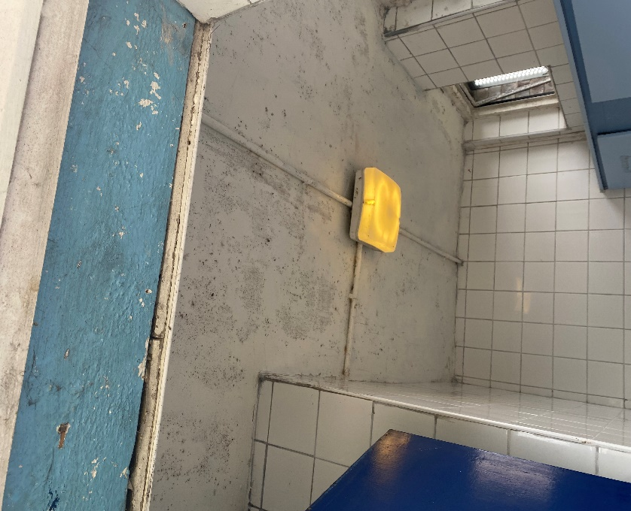
The Park interior

Funding

As you are aware, the Parish Council included in the budget for 2023/24 an additional £4,000 to be raised from the precept that would be added to our ‘Asset Maintenance Reserve’. The specific intention of this increase was to use at least part for funding of upgrades to the public conveniences.
During the year we have had to spend just under £11,000 on the replacement swings in the park. We now have remaining a figure of only £7,792 in our total ‘Asset Maintenance Reserve’ inclusive of the extra £4,000 as outline above.

Recommendations

All toilets would benefit from a power wash deep clean. It is recommended that we carry out this action as soon as possible and fund from the General Maintenance line of the budget.

The Working Group then need to consider the extent of the work that they wish to undertake within the current budget (as outlined above), and the priority of projects.

Option A: The Point – gloss and emulsion repaint interior - approx. cost of materials £350.00

Option B: The Park – gloss and emulsion repaint interior inc. replacement door and reglazing of window – approx. cost of materials £600.00

Option C: The Point – exterior repaint and clean (inc roof) – approx. cost of material £300.00

Option D: The Park – exterior repaint – approx. cost of materials £400.00

TOTAL COST = £1,650.00 (to be funded from Asset Maintenance Reserve)

Future Options

A number of Island councils have recently used a company called Danfo to help upgrade their public toilets. Examples of their work can be seen below;

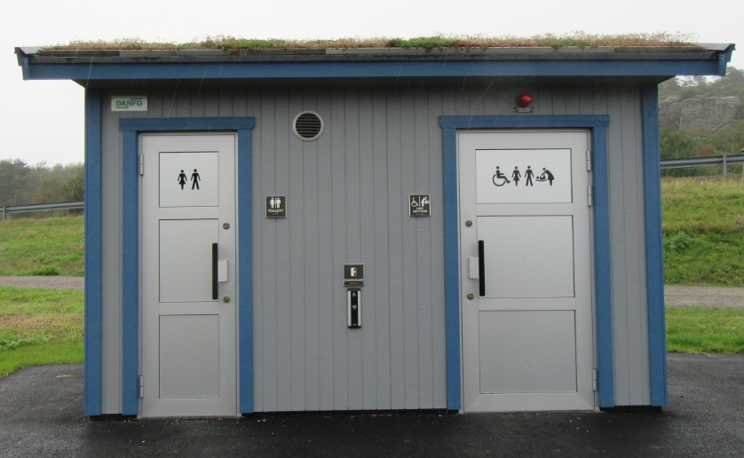
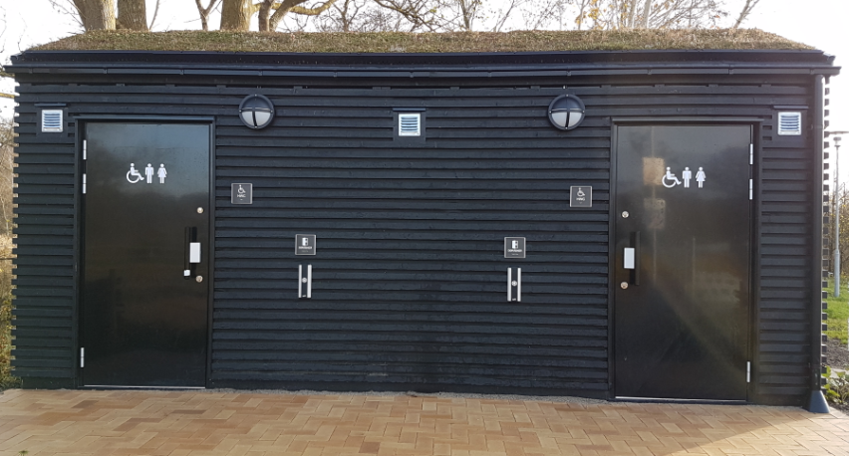
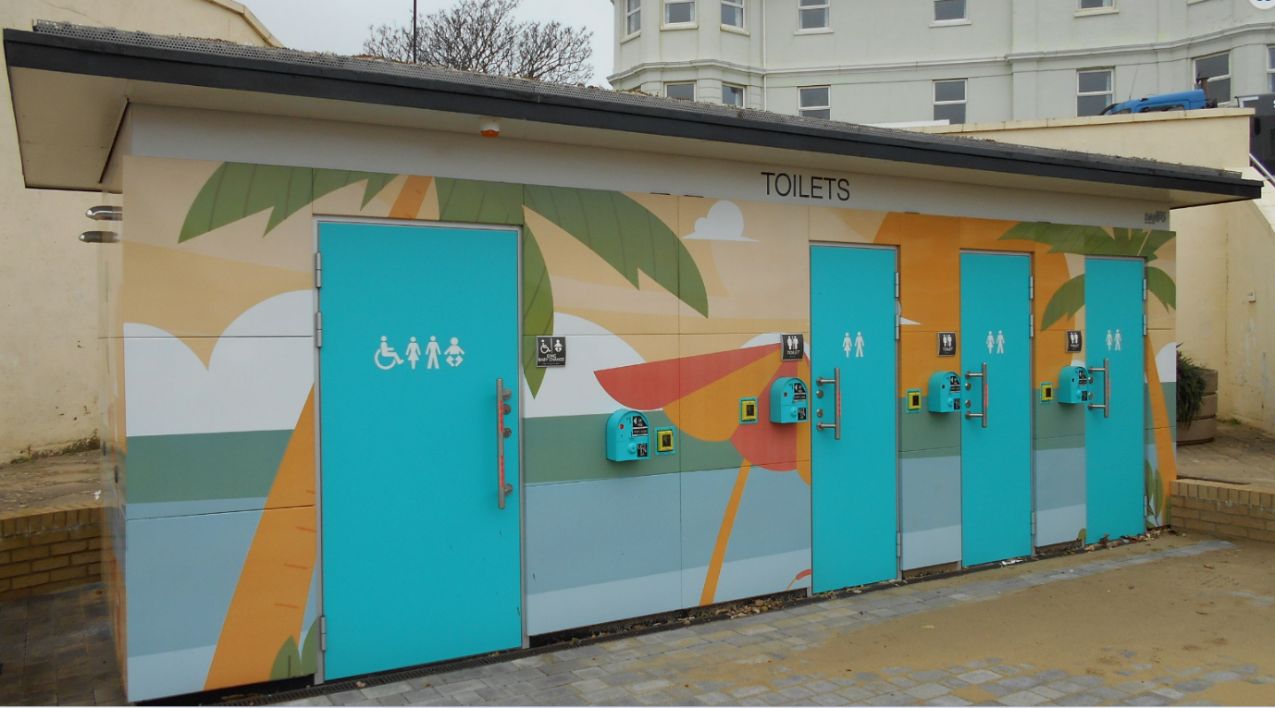

The above toilet is the new one that has been recently fitted at Sandown.

You can get more info about the project here: Public toilet for popular seaside resort Danfo

Works on this scale are likely to cost in the region of £100k - £300k and therefore should be seen as a long term project.

