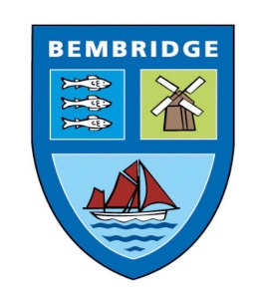
BEMBRIDGE PARISH COUNCIL

5 Foreland Road, Bembridge, Isle of Wight, PO35 5XN
Tel: 01983 874160

Village Green Report

At the Full Council meeting of 15th May 2024 agenda item 17 was presented as follows:

To receive and discuss request from Bembridge Harbour Authority with Bembridge Investments Ltd as follows:
“Bembridge Harbour Authority together with Bembridge Investments Ltd as owner of the Village Green site at Bembridge Point request the support of Bembridge Parish Council in its actions to remove all vehicles from said Village Green site in accordance with the original designation granted by the Isle of Wight Council dated 30th October 2013”.

Following discussion the Council resolved - To request Bembridge Harbour Authority and Bembridge Investments Ltd provide further clarification and definitions of ‘support’ and ‘actions’.

Further background details on Village Green:
The following is taken from Common land and village greens - GOV.UK (www.gov.uk)
There are rules on how you can use common land and town and village greens.

Common land
Common land is owned, for example by a local council, privately or by the National Trust.
You usually have the right to roam on it. This means you can use it for certain activities like walking and climbing.
Some common land has different rights, so you may be able to use it for other activities, for example horse-riding.
You cannot:
- camp on common land without the owner’s permission
- light a fire or have a barbecue
- hold a festival or other event without permission
- drive across it without permission unless you have the right to access your property

Town and village greens
You can use town and village greens for sports and recreation, for example playing football or walking your dog. Some also have ‘rights of common’ over them - like grazing livestock.
The right to roam does not apply.
Many greens are owned and maintained by local parish or community councils. Some are privately owned.
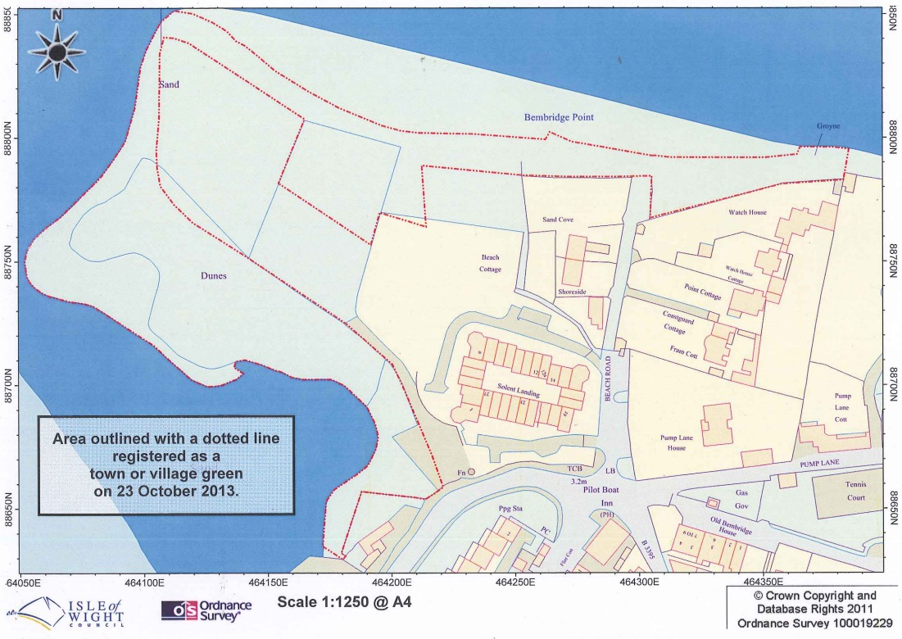

Following a meeting between Malcolm Thorpe of the Bembridge Harbour Authority, and Cllr White and Cllr Groom along with the Clerk, the BHA submitted the following:
Attn: Mark Rochell.
Good morning Mark,
I would refer to my email 09/05/2024 in respect of the Village Green at Bembridge Point that I consider was interpretated incorrectly by BPC.
I am not looking for BPC to provide any financial or physical assistance to my proposal to deal with the issues at the Village Green.
I am looking for acknowledgement of what I hope will be a further civil request to the campervans and caravans on the Village Green to remove themselves from said Village Green site in accordance with the original designation granted by the Isle of Wight Council dated 30th October 2013.
By so doing, I believe it will be a positive step forwards for BPC in the maintenance of their toilet facilities in the vicinity as well as creating less household rubbish amongst other aspects.
I believe the next BPC meeting is on Wednesday 19th June and have intentions of attending the same.

A revision of the wording of the request was suggested to be resubmitted to the Council at the 19th June meeting as follows:
‘It is requested that Bembridge Parish Council support in principle Bembridge Harbour Authority together with Bembridge Investments Ltd, as owner of the Village Green site at Bembridge Point, taking all legal reasonable action to prohibit camping and the parking of vehicles on said Village Green site, in accordance with the original designation granted by the Isle of Wight Council dated 23rd October 2013’.
Note the following:
‘Support in principle’ is a phrase in written English that expresses agreement with an idea, but not necessarily with the action or specifics being proposed¹². If you agree with or believe something in principle, you agree with the idea in general, although you might not agree with all the details or support it in every situation². For example, you might say "In principle, we support the merger, but we think the value is insufficient"².
‘Reasonable action’ refers to action that is just, rational, appropriate, ordinary, or usual in the circumstances¹. It may refer to reasonable care, cause, compensation, doubt (in a criminal trial), and a host of other actions or activities¹. In the context of finance, reasonable action means action taken by the Issuer or by the Trustee after consultation with and on the advice of the Issuer and which is lawful, practicable, does not create a risk of liability for the Issuer or the Trustee unacceptable to it and is otherwise reasonable in its effect on Holders²

Thank you,
Mark Rochell
Clerk/RFO.

